User guide
Collyers IT BTEC progress viewer
Ben Higgs

Contents
page | Contents of page
2 | Introduction
3 | Installation
4 | Setup
5 | Logging in
6 | Student navigation
7 | Teacher navigation
8 | Student and teacher options
9 | Head of subject and administrator navigation
10-13 | Head of subject and administrator options
13 | General error messages

Introduction
This program is designed to make life easier for both students and teachers when marking and keeping track of progress across the IT BTEC modules at Collyers College.
The system works by setting up users and assigning them to classes based on their IT BTEC classes at college. The system then queries live data from the moodle site and displays it in an easy to read, collective display. For the students this is a lot easier than selecting each separate piece of work and viewing the marked grade. The display that students are presented with is logically laid out and is colour coded to make your grade and feedback easier to view.
The teacher view is different to the student view. For each teacher they are presented with a view, organised by class, of all their students and their progress across each unit of work. The teacher may only view their own class and the student’s grade with no feedback. This system allows a teacher to keep track of progress online and not on local spreadsheets.
The head of subject and administrator also have a different view to the rest. This view allows the user to view all students’ progress across all classes. This level of user also has access to the management functions where the classes are made and removed, where students can be manually added, removed and their password changed, where users are added to classes and teachers promoted.
The details of classes and users are kept on a database and the site is kept on a server. This means that it is accessible outside of Collyers and requires no specific hardware.

Installation
The system requires no specific installation as it will be set up by technicians on existing servers. The serves will have to be set up; they will require php extensions and phpmyadmin version 5.5. The database will need to be imported to the server; the database will be stored under db.sql. It will need the required connections set up in constants.php.
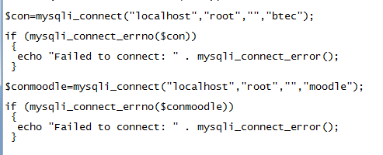
The variables $con and $conmoodle will need to be setup to match a new server. The first field on the connect statement is the server ip, then username for phpmyadmin, then the password. The last field will be kept the same.
The $conmoodle variable is the connection to the moodle server, it will need to be set up and a new user created with read only functions on phpmyadmin.
The $con variable can be on a different server to the website, however for increased speeds and ease it should be set up alongside the systems index.html file.
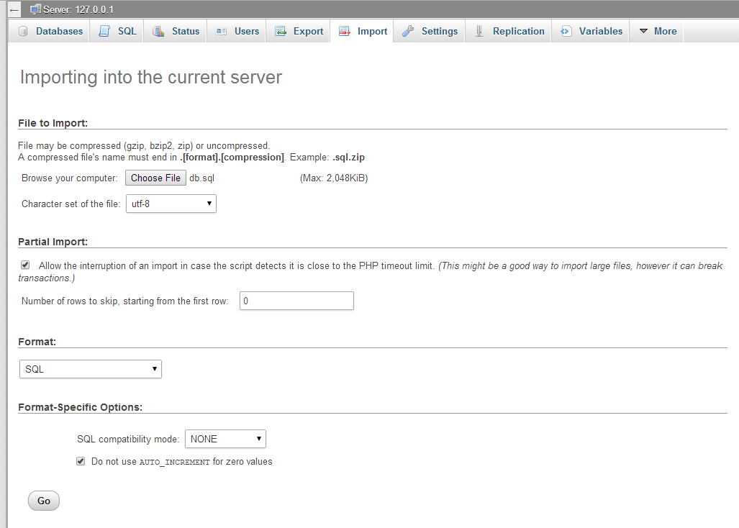
To import files to a server, use the import function on phpmyadmin and select db.sql.
To import the rest of the system to a server simply copy the files across to the new server.
Setup
Setup is needed before the system can be used.
The setup includes creating teacher users, promoting them to teachers on the system and adding classes and then once the students have logged in for the first time, adding them to their classes.

- To create users, the administrator/head of subject should use the ‘Add new user’ form in their options panel.

- Once this has been completed, the new teachers have to be promoted to teachers. To do this the administrator/head of subject should use the ‘Promote to teacher’ form in their options panel.

- To create classes, the administrator/head of subject should use the ‘Create a class’ form in their options panel.

- The next step in the setup is to add the users to their classes. Once the teacher makes sure their students have logged into and setup the system, which will allow them to see their own progress, the administrator/head of subject should add each user to the class that they are taught in.

- Now each teacher should be able to view the classes that they teach. This will work for both first and second year classes in college, so they will be able to view all of their classes.

Logging in
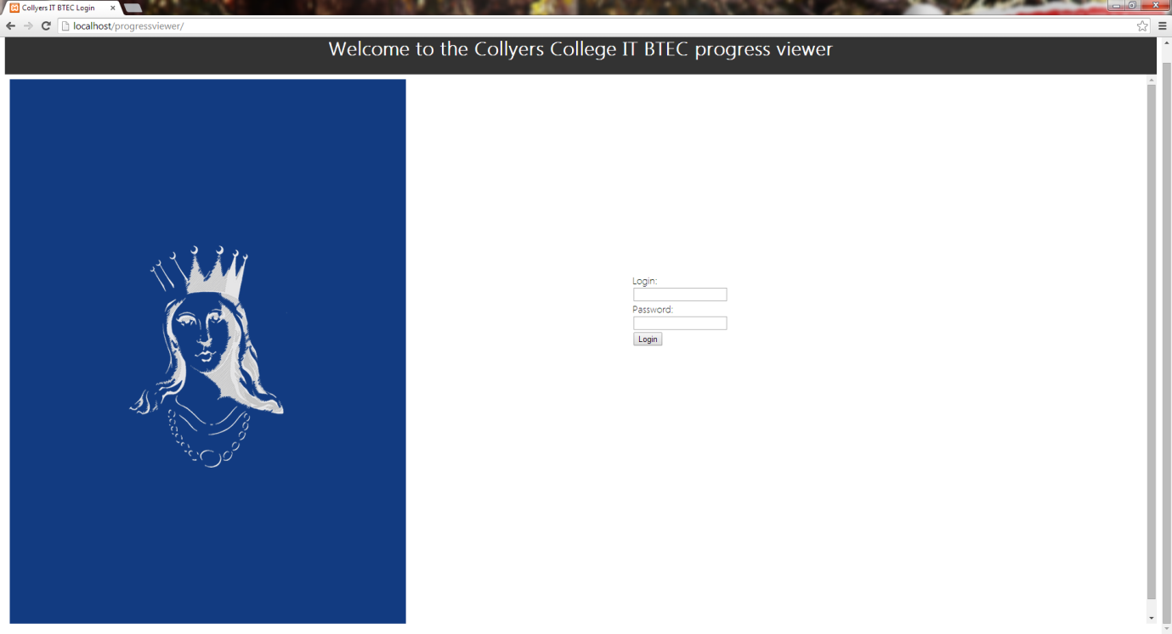
To login, use your college login and the password that you have created. This is the same for students and teachers.
Students - If this is your first login, enter your college login and leave the password field blank. It will connect to the moodle and prompt you for your first password.
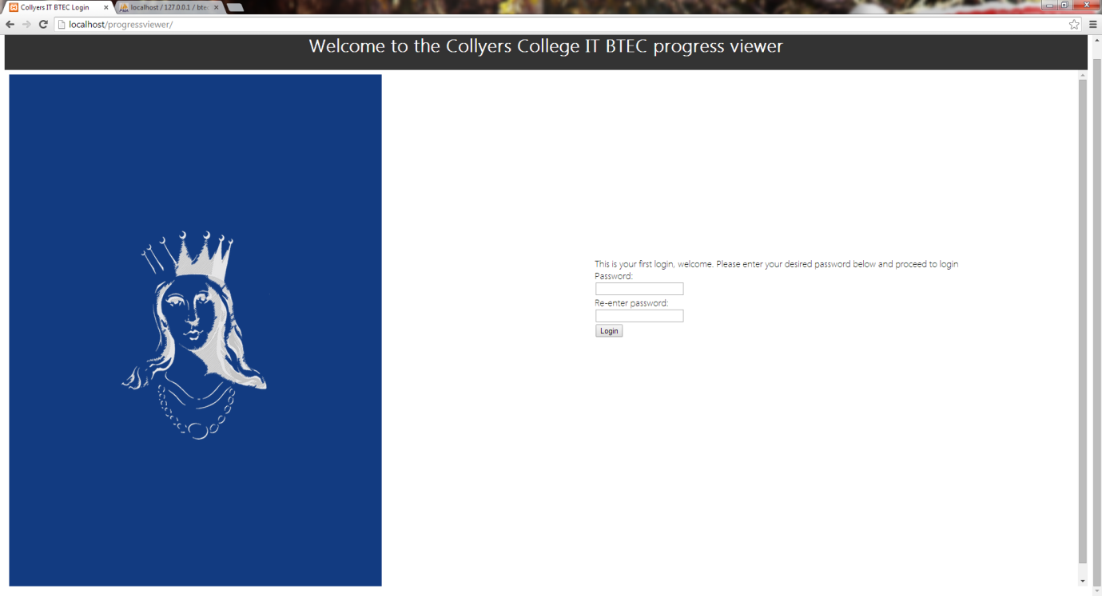

Student navigation
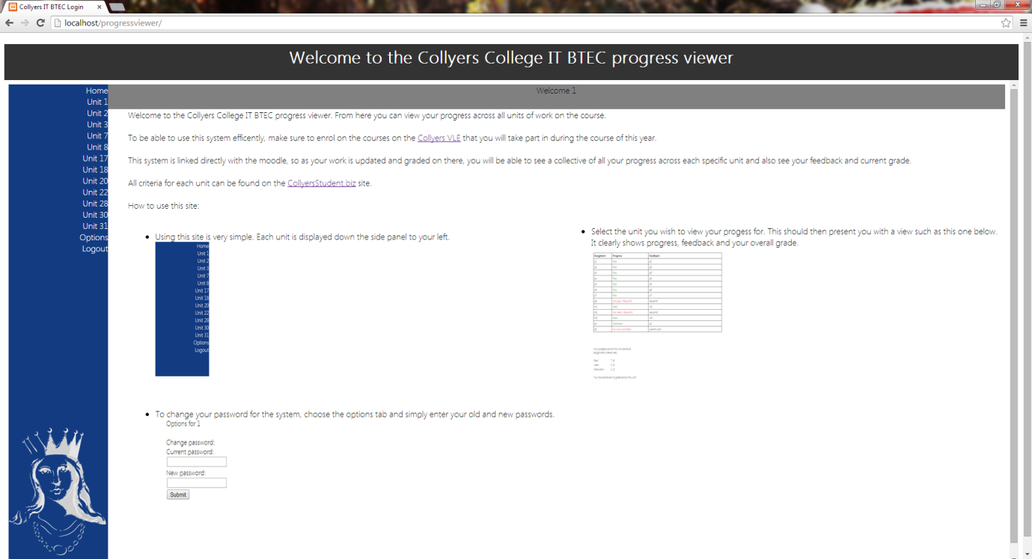
This is the home screen.
It shows you how to navigate the site and change your password.

Using the navigation panel, select what unit you wish to view your progress for. | 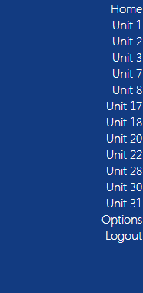
Once you have done this, you should be presented with a screen similar to this.  It will obviously depend on your progress and will clearly show your grading, your feedback and a short summary of your personal progress across this unit at the bottom. | 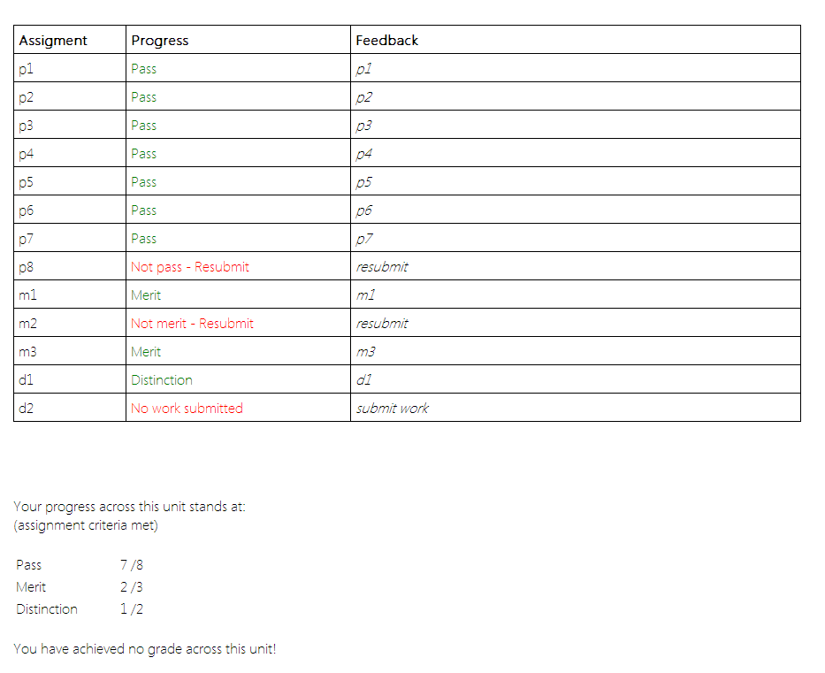
Teacher navigation
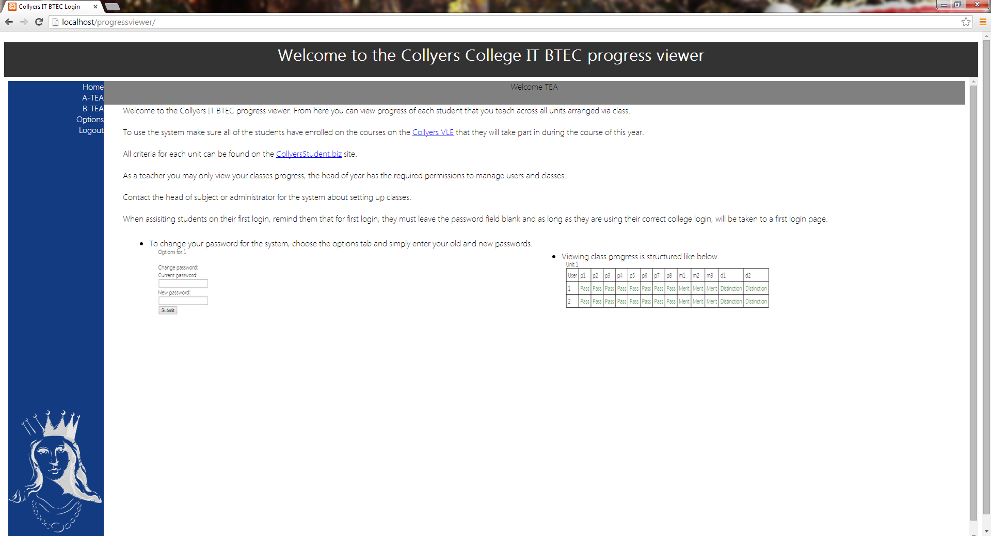
This is the home screen.
It shows you how to navigate the site and change your password.

Using the navigation panel, select which of the classes you teach you would like to view progress for. | 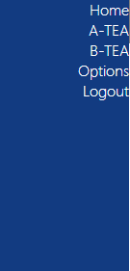
Once you have done this, you should be presented with a screen similar to this.  Obviously it will include more students, their real progress and more grades across more units. | 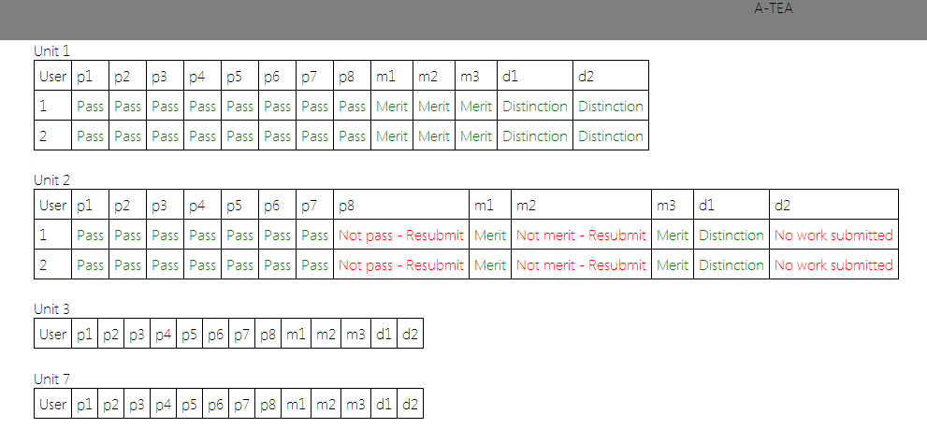

Teacher and student options
The options for both students and normal teachers are very limited; you may only change your current password. To do this

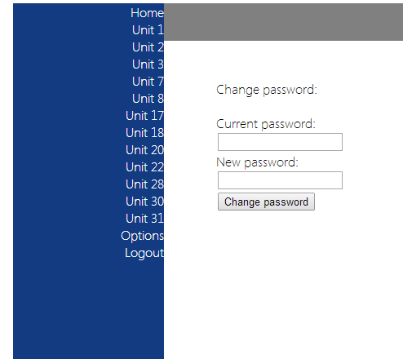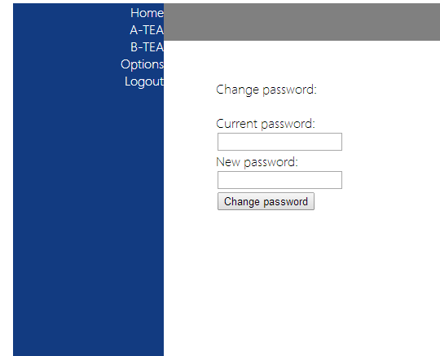
This is a view of the student and teacher options. As you can see they are both the same.
To change password, simply enter your current password and the new one below.

Display messages
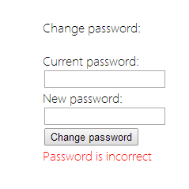 | This error message is shown when one of the passwords entered is either blank or is not the same to the old password.  To overcome this, enter the correct password or a password in the new password field
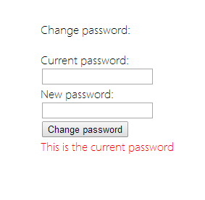 | This error message is shown when the new password entered is the same as the old one.  To overcome this, enter a new password into the new password field.
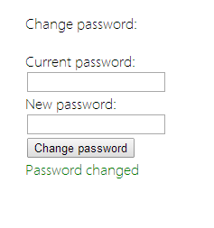 | This message is displayed when the old password is changed.
Head of subject and Administrator navigation
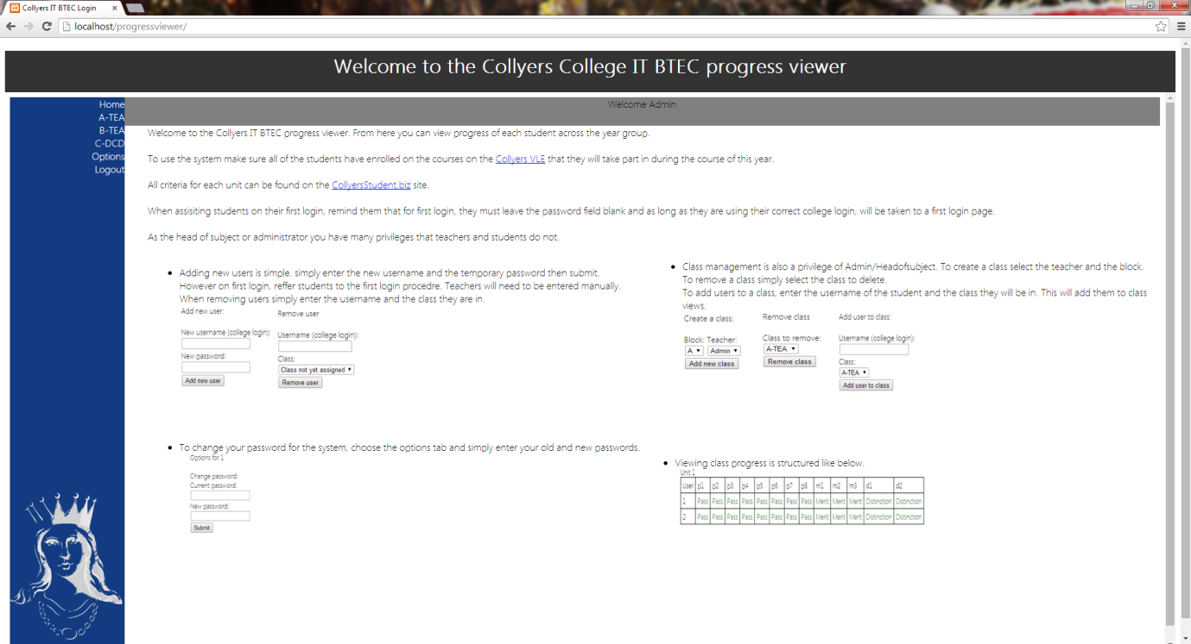
This is the home screen.
It shows you how to navigate the site and access the restricted options.

Using the navigation panel, select which of the classes you would like to view progress for.  As you can see, the admin view includes access to all of the classes. | 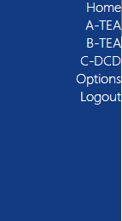
Once you have done this, you should be presented with a screen similar to this.
Obviously it will include more students, their real progress and more grades across more units.
Head of subject and Administrator options
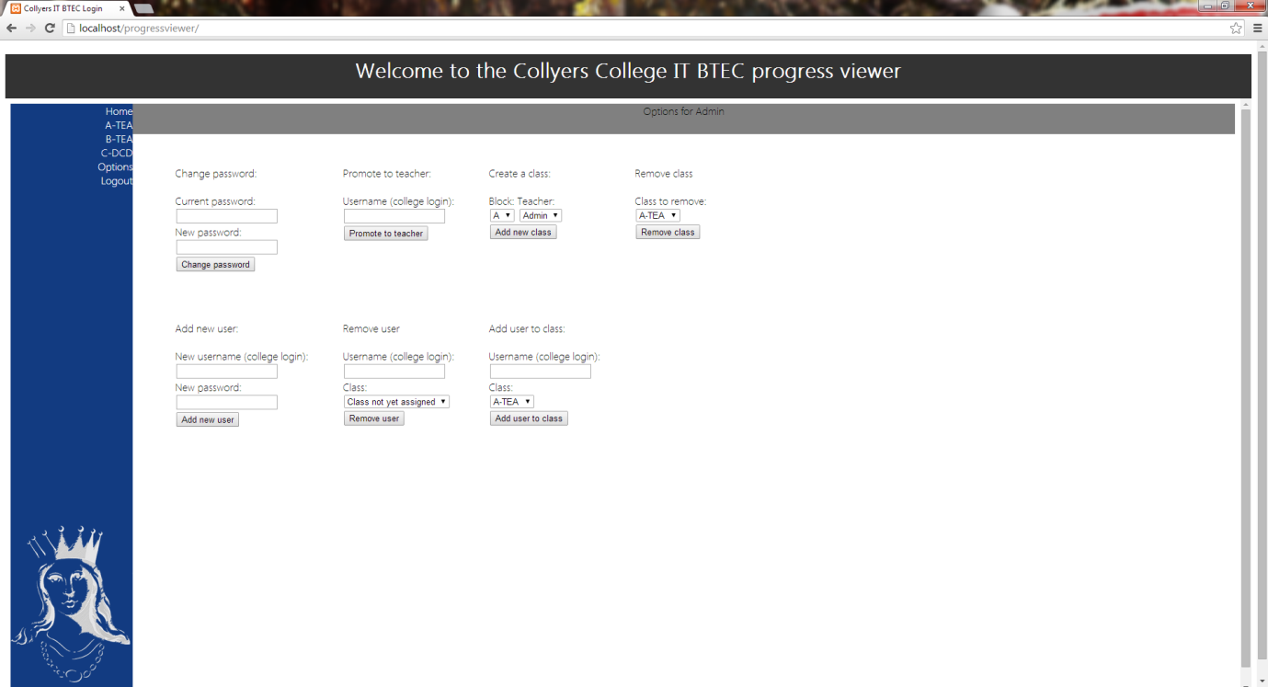
As you can see the options available for the head of subject or the administrator are much more advanced than usual.

Changing password

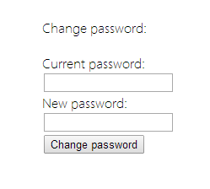 | To change password, simply enter your current password and the new one below.
Display messages | Explanations  - This is when one of the passwords is incorrect. Enter the correct password or a real password in the boxes.  - This is when the new password is the same as the old password. Enter a new password to overcome this.  - This is displayed when the password is changed.
User management
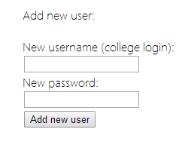 | To add a new user, enter the new username and a temporary password.  Note this should not be used for adding students, only teachers.  Students will be added automatically when they go through the first login process.
Display messages | Explanations  - This is shown when the username or password fields are blank on form submit. You must enter valid data.  - This is when the user being added already exists. To overcome this enter a different username  - This is displayed when the user has been added.
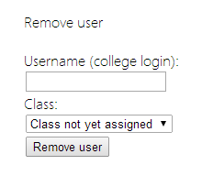 | To remove a user, enter their username and the class that they are assigned to.  If they are a teacher, you cannot remove them and must contact it support to remove them and their classes manually from the database.  If the user was an accident and has not been assigned a class, leave the class as not assigned.
Display messages | Explanations  - This is where the username entered is incorrect or no longer exists.  - This is shown when the user you are trying to remove a teacher.  - When the incorrect class is chosen for the student. You must select the correct class or select no class.  - This is displayed when the user has been removed.
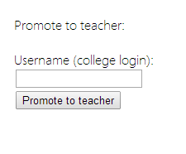 | To promote a user to teacher, make sure they haven’t been assigned a class and simply enter their name into the field. Once submitted, the form will make the user a teacher, which means they can have classes assigned to them.
Display messages | Explanations  - This is shown when the username is incorrect. You must enter an existing username.  - This is shown when the user is already a teacher.  - This is displayed when the user is promoted to a teacher.
Class management
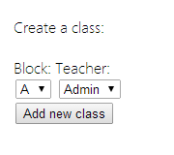 | To create a class, simply choose what teacher it will be taught by and choose the block it will be taught in.
Display messages | Explanations  - This is shown when the class already exists; you must choose another block or teacher.  - This is shown when the class is added.
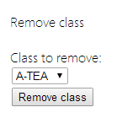 | To remove a class, all you must do Is select which class to remove then click remove.  This will automatically free up students in these classes and will allow them to be added to a different class.
Display messages | Explanations  - This is shown when the class is removed.
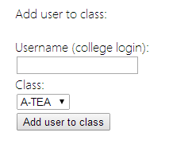 | To add a user to class, you must enter the username of the student to add to a class and then select which class to add them to.
Display messages | Explanations  - This is shown when the username entered is incorrect. To overcome this you must enter a current username.  - This is shown when the user is already in a class.  - This is shown when the user has been added to the class.

General error messages
Logging in
 | This is when the username entered is either blank or non-existent. |  | You must enter a valid, current username.
 | This is when the password entered is blank or incorrect. |  | You must enter a valid, current password for the specified user account.
 | This is when the first login page is reached by a new user, and the passwords entered to not match up. |  | You must enter two valid passwords that do match up.
Student navigation
This error message is shown when the unit you are trying to view you have not enrolled on using the Collyers VLE. |  | You must enrol on the course on the Collyers VLE to view your progress.

